**PROJECT REPORT**

**AGRICULTURE DOCS CHAIN**

**INTRODUCTION**

* 1. **Project Overview**

The "Agriculture Docs Chain" project is a blockchain-based system designed to revolutionize the management of documents and data within the agriculture industry. By utilizing blockchain technology, this initiative aims to enhance transparency, traceability, and security in the agricultural supply chain.

Through the Agriculture Docs Chain, various stakeholders such as farmers, distributors, retailers, and regulatory bodies can securely and efficiently share, verify, and track important documents related to agriculture. This includes documents like certificates of authenticity, inspection reports, shipping records, and more.

The primary goals of this project are to reduce fraud, streamline processes, and improve overall trust within the agricultural ecosystem, ultimately leading to safer and more reliable food production and distribution. Blockchain's immutability and decentralized nature make it a promising solution for tackling longstanding challenges in the agricultural industry, ensuring that data and documentation are accurate, accessible, and tamper-proof.

* 1. **Purpose :**

Agriculture is a critical industry that can benefit from the implementation of blockchain technology for various purposes. The purpose of an agriculture document chain using blockchain can encompass several key objectives.

**Supply Chain Transparency:** Blockchain can be used to create a transparent and immutable record of every step in the agricultural supply chain, from planting to harvesting, processing, packaging, and distribution.

**Provenance and Traceability:** Blockchain can enable consumers and stakeholders to trace the origin of agricultural products. This can be used to verify the authenticity of organic or specialty products.

**Quality Control and Certification:** Agriculture documents on the blockchain can include certificates of organic farming, fair trade, and other quality standards.

**2. LITERATURE SURVEY**

**2.1 Existing Problems :**

A literature survey of existing problems in agriculture document chains using blockchain reveals a range of challenges and issues that researchers and practitioners have identified. These issues span various aspects of the agriculture industry and blockchain technology.

Blockchain networks can experience scalability challenges when dealing with a large number of transactions and documents. The consensus mechanism and the need for all nodes to validate transactions can slow down the network, leading to potential bottlenecks.

While blockchain offers security through encryption, private keys, and immutability, ensuring the privacy of sensitive agricultural data remains a concern. Unauthorized access to data or breaches can have significant consequences. Many agricultural stakeholders may lack the technical expertise to effectively utilize and manage blockchain technology. Training and education are essential but may be lacking.

The regulatory landscape for blockchain in agriculture is still evolving. Legal and regulatory uncertainties can hinder adoption and raise concerns regarding data ownership, liability, and compliance.

The agriculture industry has a history of traditional practices, and resistance to change can be a significant obstacle to adopting blockchain solutions.Researchers and practitioners continue to work on addressing these challenges in the agriculture document chain using blockchain. It's important to recognize that blockchain technology is not a one-size-fits-all solution, and its implementation should be carefully tailored to the specific needs and constraints of the agricultural sector. Additionally, collaboration between various stakeholders, including government agencies, industry players, and technology providers, is crucial for addressing these issues effectively.

**2.2 References :**

1. A. E. Mane, M. Chihab, O. Bencharef, and C. Younes, “Architectural scheme of a multi-Blockchain in the Agricultural field,” E3S Web of Conferences, vol. 297, no. 4, 2021.
2. H. Patel and B. Shrimali, “AgriOnBlock: Secured data harvesting for agriculture sector using Blockchain technology,” ICT Express, vol. 10, 2021.
3. Christidis K, Devetsikiotis M , “Blockchains and Smart Contracts for the Internet of Things” , IEEE Access, 4 (2016).
4. Lin J, Zhang A, Shen Z, Chai Y. Blockchain and IoT based food traceability for smart agriculture. ACM International Conference Proceedings Series 2018.
5. Menon, S.; Jain, K. Blockchain Technology for Transparency in Agri-Food Supply Chain: Use Cases, Limitations, and Future Directions. IEEE Trans. Eng. Manag. 2022.
6. S. Sinha, A. S. Shankar, P. Rai , "Blockchain Technology in Agriculture: Applications, Challenges, and Opportunities", 2020 11th International Conference on Computing, Communication and Networking Technologies (ICCCNT).
7. Pedro Pereira, Sérgio Guerreiro, "Blockchain and Smart Contracts for the Food Supply Chain: A Review on Sustainability and Future Challenges", 2021 Sustainability.
8. Muhammad Kamran, Shang Gao, et al , "Blockchain Technology in Agriculture: Enhancing Transparency and Traceability in the Food Supply Chain" , 2019 IEEE 9th Annual Computing and Communication Workshop and Conference (CCWC).
9. Gabriel Gustavo Oviedo Lugo, Muhammad Ali Babar , "Blockchain Technology and Agriculture: A Systematic Mapping Study" , 2021 IEEE Access.
10. Mukta Athale, Shyam Varan Nath , "A Survey on the Role of Blockchain in Agriculture" , 2018 International Conference on Inventive Computation Technologies (ICICT).

**2.3 Problem Statement Definiton :**

In the agriculture industry, there exists a pressing need for a secure, transparent, and efficient system to manage and verify various documents and data points throughout the agricultural supply chain, from farm to consumer. Current paper-based and disjointed digital systems often result in data discrepancies, inefficiencies, and lack of trust among stakeholders.

Ensuring the authenticity of documents, such as certifications, quality reports, and transaction records, is a challenge, leading to issues like fraud, counterfeiting, and difficulties in traceability. Furthermore, the lack of data interoperability, limited access to financial services, and regulatory uncertainties present significant barriers to the industry's growth and sustainability.

To address these multifaceted challenges, a blockchain-based document chain solution must be developed that ensures data integrity, transparency, and accessibility while considering the unique requirements and constraints of the agriculture sector.

The vulnerability of sensitive agricultural data to security breaches, unauthorized alterations, or data manipulations presents a significant risk. Current systems may lack the robust security measures required to safeguard confidential information, posing threats to the integrity and authenticity of agricultural documents.

The vulnerability of sensitive agricultural data to security breaches, unauthorized alterations, or data manipulations presents a significant risk. Current systems may lack the robust security measures required to safeguard confidential information, posing threats to the integrity and authenticity of agricultural documents.

The evolving regulatory landscape poses uncertainty regarding legal frameworks, compliance standards, and data ownership rights in blockchain-based agricultural documentation. This uncertainty inhibits the full-scale adoption of blockchain technology.

Implementing blockchain technology in the agriculture sector requires significant investments in infrastructure, expertise, and technology, which can be financially burdensome for smaller agricultural entities. Moreover, the technical complexities of integrating blockchain with existing agricultural systems create barriers to adoption.

In summary, the problem statement for an agriculture document chain using blockchain is centered on the need to overcome the current inefficiencies, lack of transparency, and authenticity issues in the management of agricultural documents through the implementation of a blockchain-based solution tailored to the unique challenges and requirements of the agriculture sector.

**3. IDEATION & PROPOSED SOLUTION**

**3.1 Empathy Map Canvas :**

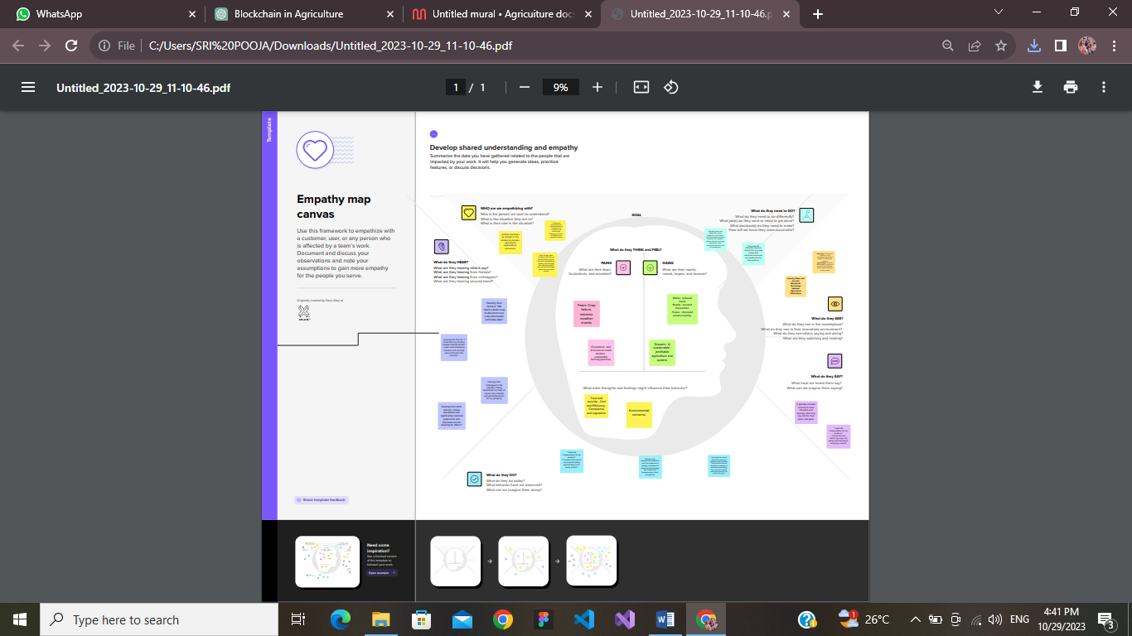

**3.2 Ideation and Brainstorming :**

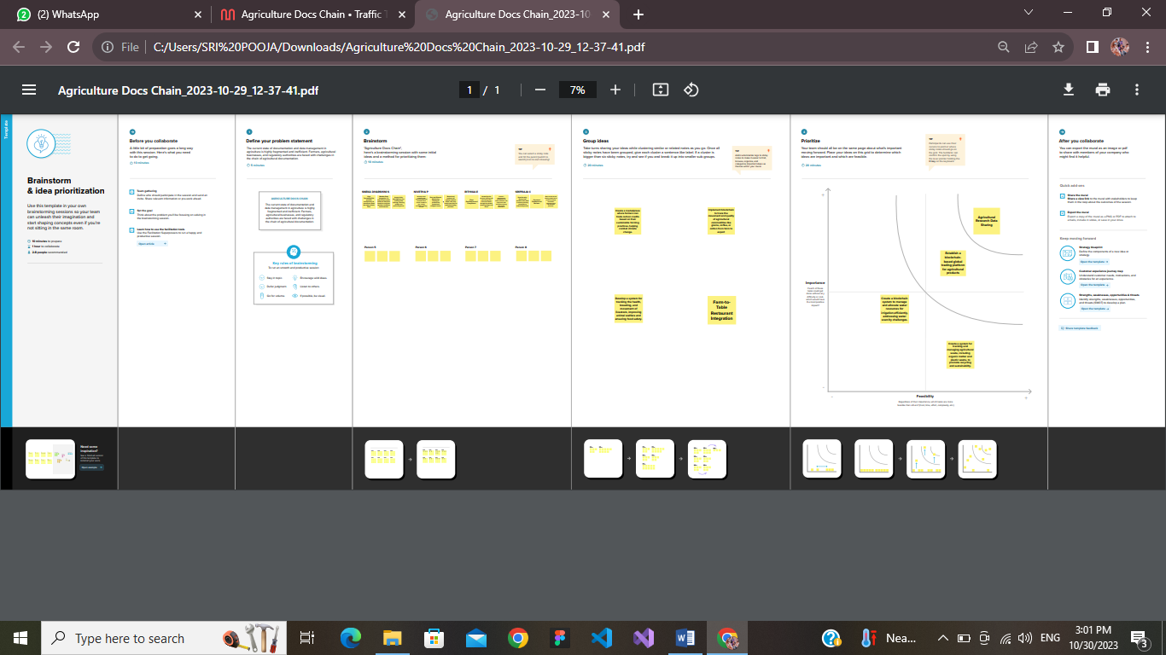





**4.REQUIREMENT ANALYSIS**

**4.1 Function Requirement :**

Functional requirements for an agriculture document chain using blockchain specify the features and capabilities that the system must have to address the identified problems.

**User Registration and Authentication:**

* Users, including farmers, distributors, and regulatory bodies.
* it should be able to register and authenticate themselves on the blockchain platform securely.

**Smart Contracts for Transactions:**

* Implement smart contracts to automate and enforce agreements, such as payment upon delivery, between parties in the agriculture supply chain.
* Smart contracts can facilitate trust and streamline transactions.

**Document Traceability:**

* Enable users to trace the origin and history of agricultural products by accessing the document history on the blockchain.

This feature is crucial for ensuring transparency and accountability.

**Consensus Mechanism:**

* Define and implement the appropriate consensus mechanism for the blockchain network.
* Its taking into account scalability, energy efficiency, and security requirements.

**Scalability and Performance:**

Design the system to handle a high volume of transactions and documents efficiently, with scalability in mind to accommodate future growth.

Thesefunctional requirements are essential for creating a robust and effective agriculture document chain using blockchain technology. The system should be designed to address the specific needs and challenges of the agriculture sector while providing a secure, transparent, and efficient platform for managing agricultural documents.

**2.2 Non-Functional requirements:**

**Security:**

* **Data Security:** The system should ensure the confidentiality, integrity, and availability of agricultural documents, protecting them from unauthorized access or tampering.
* **User Authentication:** Implement strong and secure methods for user authentication to prevent unauthorized access to the blockchain platform.
* **Privacy:** Ensure the privacy of sensitive agricultural data, allowing users to control who can access their documents and personal information.

**Performance:**

* **Throughput:** The system should be able to handle a high volume of transactions, ensuring quick processing and confirmation on the blockchain.
* **Response Time:** Transactions and queries should have low latency for a seamless user experience.
* **Scalability:** The system should be able to scale horizontally to accommodate growing data and user loads.

**Usability:**

**User Experience (UX):** Create a user-friendly interface for stakeholders to interact with the blockchain system.

**Accessibility:** Ensure that the system is accessible to a diverse range of users, including those with disabilities.

**Auditability:**

**Transaction Traceability:** Enable a robust audit trail for transactions, allowing for easy tracking and verification.

**Adaptability:**

* **Technology Agnosticism:** Be prepared to adapt to changes in blockchain technology and standards.
* **Market Changes:** The system should adapt to changes in the agricultural market and supply chain practices.

**5. PROJECT DESIGN**

**5.1 Data Flow Diagram & User Stories:**

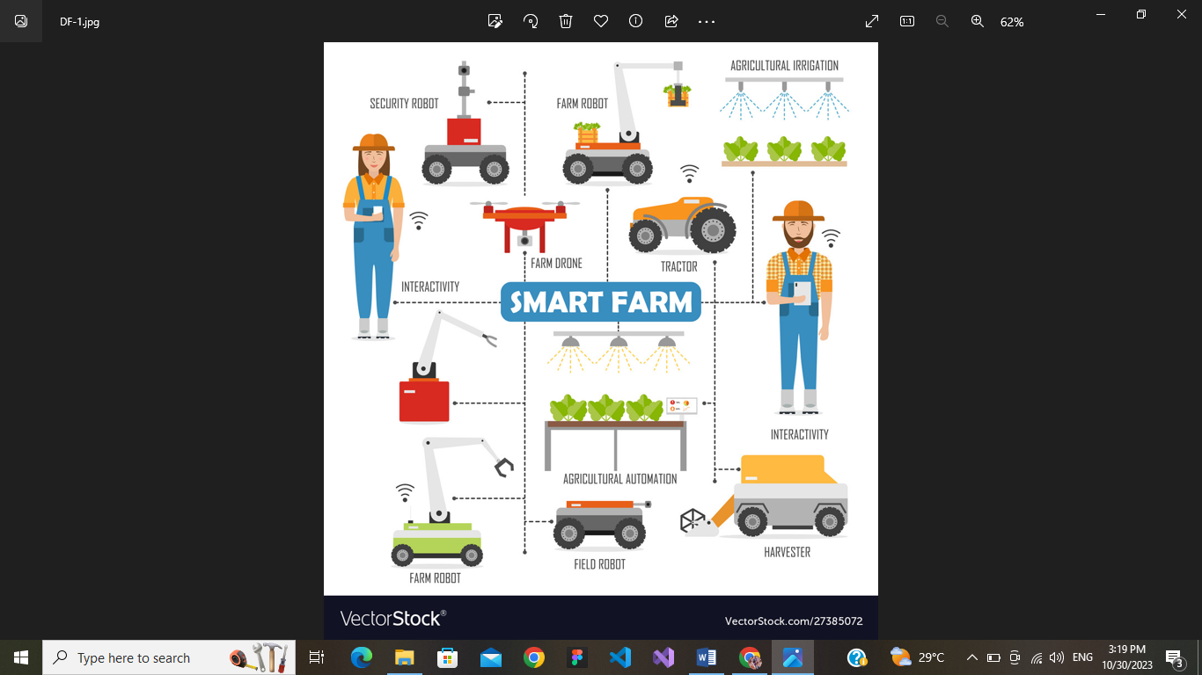

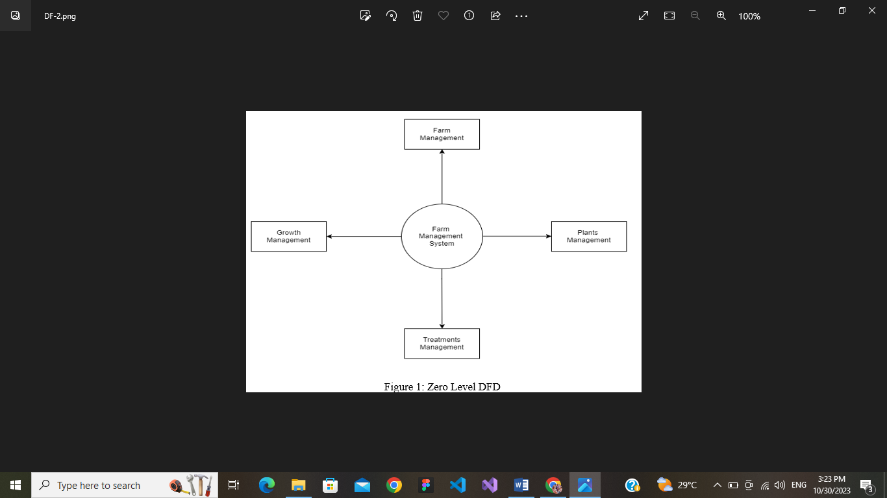

**5.2 Solution Architecture :**

Solution architecture is a complex process – with many sub-processes – that bridges

the gap between business problems and technology solutions. Its goals are to:

• Find the best tech solution to solve existing business problems.

• Describe the structure, characteristics, behavior, and other aspects of the

software to project stakeholders.

• Define features, development phases, and solution requirements.

• Provide specifications according to which the solution is defined, managed, and delivered.

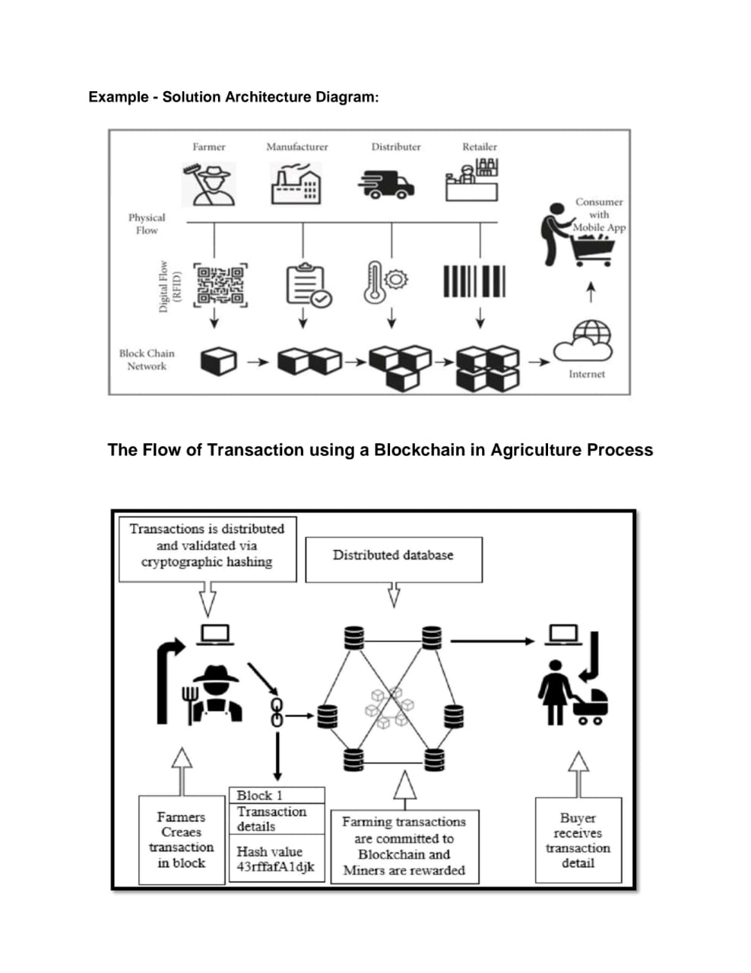

**6. PROJECT PLANNING**

**6.1 Technical Architecture :**

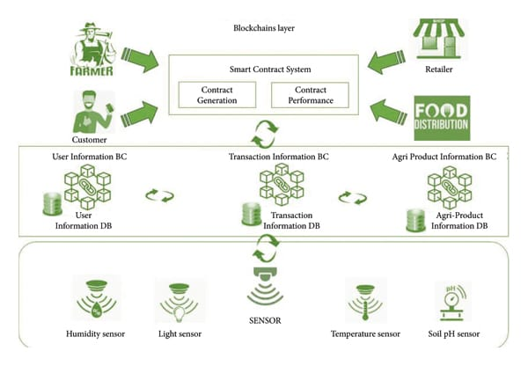

**7. CODING AND SOLUTIONING**

**Source code :**

contract AgricultureDocsChain {

struct Document {

string name;

string description;

address owner;

}

mapping(uint256 => Document) public documents;

uint256 public documentCount;

event DocumentAdded(uint256 indexed id, string name, string description, address indexed owner);

constructor() {

documentCount = 0;

}

function addDocument(string memory _name, string memory _description) public {

documentCount++;

documents[documentCount] = Document(_name, _description, msg.sender);

emit DocumentAdded(documentCount, _name, _description, msg.sender);

}

}

**8.PERFORMANCE TESTING**

|  |  |  |  |
| --- | --- | --- | --- |
| **S.No.** | **Parameter** | **Values** | **Screenshot** |
| 1. | Informationgathering | SetupallthePrerequisite: |  |
| 2. | Extractthezipfiles | Opentovscode |  |
| 3. | Remix Ide platformexplorting | Deploythesmartcontractcode Deployandrunthetransaction.Byselecting the environment - injecttheMetaMask. |  |
| 4. | Open file explorer | Open the extracted file and click on the folder.  Open src, and search for utiles.  Open cmd enter commands 1.npm install   1. npm bootstrap   npm start |  |
| 5. | {LOCALHOST IP ADDRESS | copy the address and open it to chrome so you can see the front end of your project. |  |

**9. RESULTS**

**9.1 Output Screenshots :**

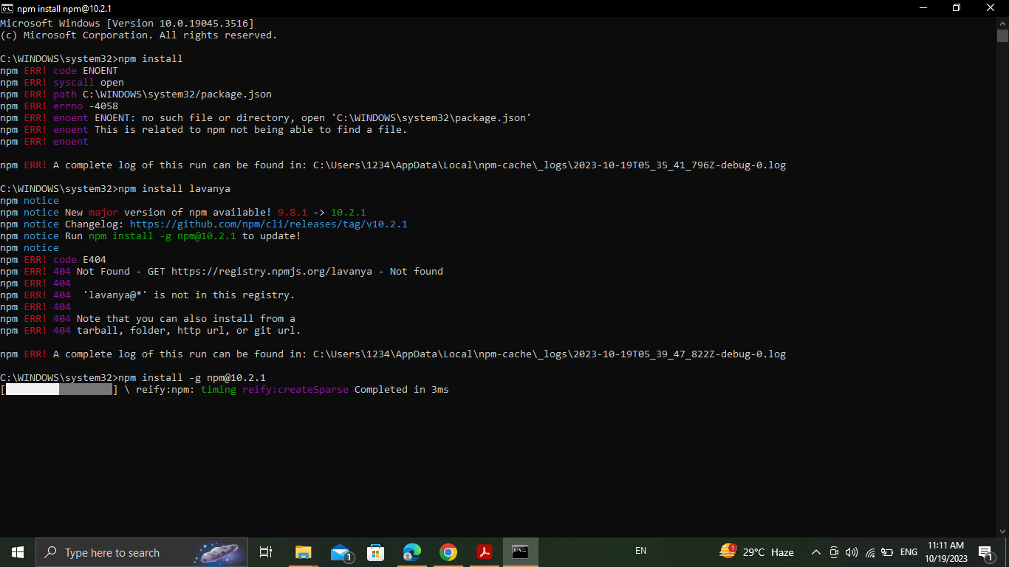

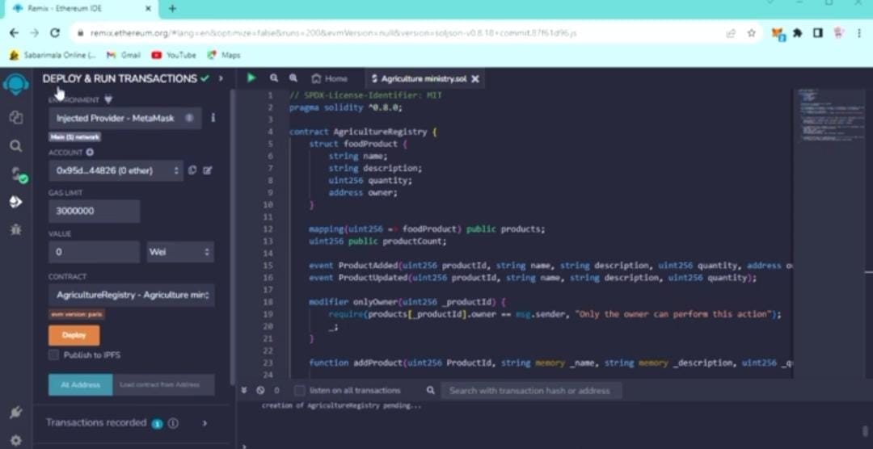

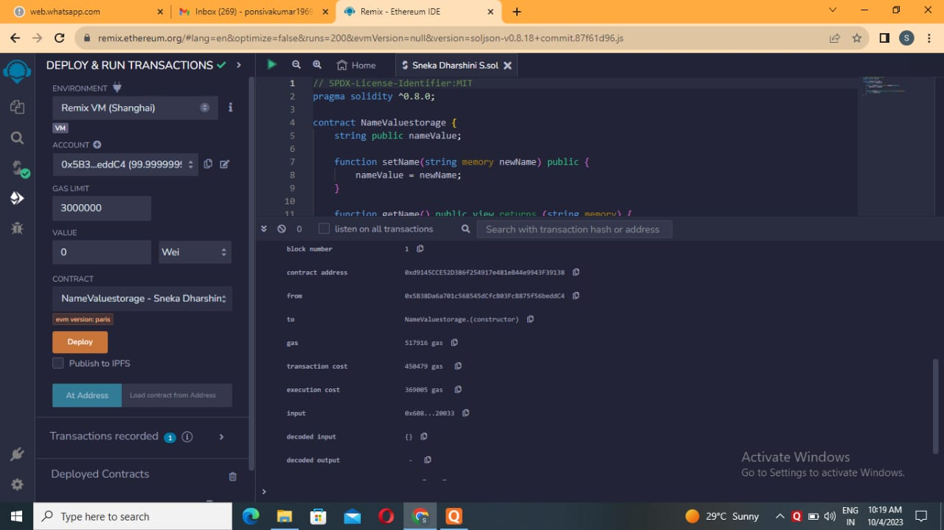

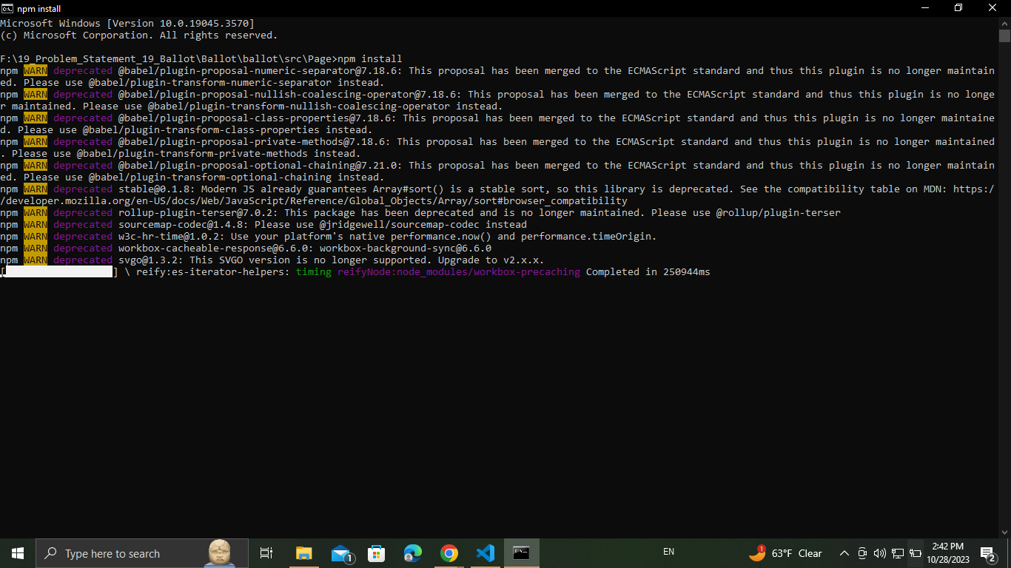

**10. ADVANTAGES & DISADVANTAGES**

**10.1 Advantages :**

1. **Data Security:** Blockchain technology provides a highly secure and immutable ledger for storing agricultural documents, reducing the risk of data tampering and unauthorized access.
2. **Transparency :** All participants in the agricultural ecosystem, from farmers to consumers, can access and validate information on the blockchain, promoting trust and transparency.
3. **Traceability :** Blockchain enables end-to-end traceability of agricultural products, allowing consumers to verify the origin and quality of the food they purchase.
4. **Reduced Fraud :** Blockchain's immutability and transparency can help reduce fraud in areas like certification of organic products or land ownership, as records cannot be altered without consensus.
5. **Smart Contracts :**Automation through smart contracts streamlines processes such as payment settlements, reducing administrative overhead and the risk of errors.
6. **Efficient Supply Chain :** Blockchain can optimize the supply chain by providing real-time visibility into the movement of goods, helping reduce delays, errors, and losses.
7. **Ownership Verification :** Land and asset ownership records on the blockchain can help prevent land disputes and simplify the process of verifying ownership.
8. **Enhanced Consumer Confidence :** Consumers can make more informed choices about the products they purchase, knowing they can trust the information on the blockchain.

**10.2 Disadvantages :**

1. **Adoption Challenges:** Implementing a blockchain-based supply chain system in agriculture requires the participation and cooperation of multiple stakeholders, including farmers, distributors, and government agencies. Getting all parties on board can be challenging.
2. **Cost:** Developing and maintaining a blockchain network can be expensive, and this cost might be prohibitive for smaller farmers or businesses in the agriculture industry.
3. **Technical Expertise:** Using blockchain technology requires technical expertise, which may be lacking in some agricultural communities. Training and support may be necessary for successful adoption.

**11. CONCLUSION**

In conclusion, implementing a blockchain-based documentation and supply chain system in agriculture offers numerous benefits, such as increased transparency, traceability, and efficiency. It has the potential to revolutionize the industry by reducing fraud, ensuring food safety, and improving the overall quality of agricultural products. However, it also comes with challenges and potential disadvantages,including adoption hurdles, costs, technical expertise requirements, data privacy concerns, scalability issues, connectivity limitations, interoperability challenges, and legal and regulatory complexities.

The successful adoption of blockchain in agriculture will depend on addressing these disadvantages, fostering collaboration among stakeholders, and providing the necessary infrastructure and support. As the technology continues to evolve, it holds great promise for improving the sustainability and integrity of the agricultural supply chain, benefiting both producers and consumers.

**12. FUTURE SCOPE**

Using blockchain for agriculture has enabled farmers to earn more returns as compared to traditional approaches. In the future, the implementation of blockchain technology offers a promising solution to create a safer, more reliable, sustainable, and more efficient agri-food system.

**13.APPENDIX**

**13.1 Source Code:**

pragma solidity ^0.8.0;

contract AgricultureRegistry {

struct foodProduct {

string name;

string description;

uint256 quantity;

address owner;

}

mapping(uint256 => foodProduct) public products;

uint256 public productCount;

event ProductAdded(uint256 productId, string name, string description, uint256 quantity, address owner);

event ProductUpdated(uint256 productId, string name, string description, uint256 quantity);

modifier onlyOwner(uint256 _productId) {

require(products[_productId].owner == msg.sender, "Only the owner can perform this action");

_;

}

function addProduct(uint256 ProductId, string memory _name, string memory _description, uint256 _quantity) external {

products[ProductId] = foodProduct(_name, _description, _quantity, msg.sender);

productCount++;

emit ProductAdded(productCount, _name, _description, _quantity, msg.sender);

}

function updateProduct(uint256 _productId, string memory _name, string memory _description, uint256 _quantity) external onlyOwner(_productId) {

foodProduct storage product = products[_productId];

product.name = _name;

product.description = _description;

product.quantity = _quantity;

emit ProductUpdated(_productId, _name, _description, _quantity);

}

function getProductDetails(uint256 _productId) external view returns (string memory name, string memory description, uint256 quantity, address owner) {

foodProduct memory product = products[_productId];

return (product.name, product.description, product.quantity, product.owner);

}

}

**14. GITHUB LINK:** [**https://github.com/Snekadharshini-GITHUB/NM2023TMID01749**](https://github.com/Snekadharshini-GITHUB/NM2023TMID01749)

**VIDEO LINK:** [**https://drive.google.com/file/d/1nJU7FRXEjEFF11Jzbx7VOc5kUMFrcctG/view?usp=drivesdk**](https://drive.google.com/file/d/1nJU7FRXEjEFF11Jzbx7VOc5kUMFrcctG/view?usp=drivesdk)